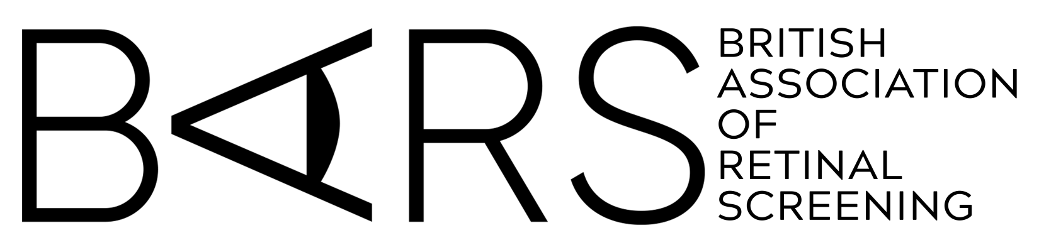

22nd CONFERENCE
26-27 September 2024

www.eyescreening.org.uk

CALL FOR POSTERS

If you wish to submit a poster (A0 portrait) at the 2024 BARS Conference, please complete this form and return it to us via e-mail or post to the address on page 2.

Submissions must be received before the closing date of 31 July 2024.

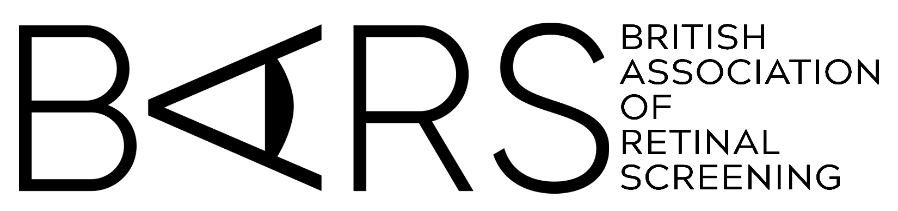

This year we are offering an Amazon Voucher for the best poster of £300 submitted plus a runner-up prize of £200 and a 3rd prize of £100.

To submit your proposal, please enter the following information and
then follow the instructions at the end of this form.

Proposed title of your Poster:

Brief description of your Poster:

Your full name, including title:

Your job title and organisation:

Are you a BARS member? YES / NO

Your postal address:

Your telephone number:

Your e-mail address:

Posters will be available to view for the duration of the conference and you should be available to stand by and discuss your poster with the judges during the scheduled 3rd break on Friday 27 September. Please be advised that BARS may publish some of the posters on its website.

Please confirm, by signing below, that you are willing for your poster to be published, that you have permission to share any clinical information it contains, and that your poster does not infringe on another person’s copyright.

Signed ………………………………..…………. Date ……………………

If submitting via e-mail please add your full name above and send from an e-mail address that includes that name. If printing, please sign and send to the postal address below.

Please return to: Or e-mail to:
Mrs Alison Simpson barsevents@eyescreening.org.uk
BARS Co-ordinator
Ophthalmology Department
Ward 25
Ninewells Hospital
Dundee DD1 9SY

You will be contacted shortly after the closing date with the outcome of your submission.

